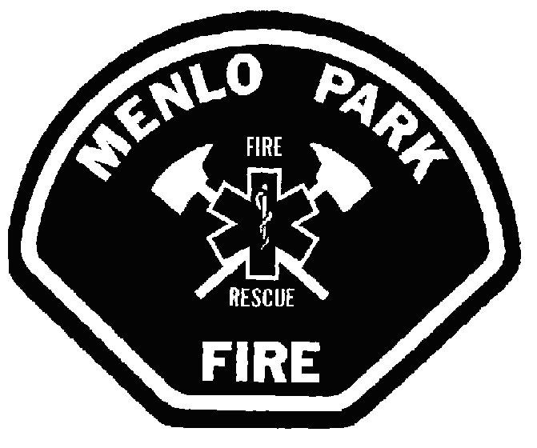
Notice of Claim

Directions
- Either complete the form electronically or print this form out and complete by hand.
- Complete all sections relating to this claim, print and sign the form.
- Attach any supporting documents to this claim and mail it within 180 days from the date of the incident to:
Menlo Park Fire Protection District
Attn: Custodian of Records
170 Middlefield Road
Menlo Park, CA 94025

Claimant Information
First Name: | Last Name:
Home Phone #: | Email:
Address:

Attorney or Representative Information
First Name: | Last Name:
Home Phone #: | Email:
Address:
Relationship to the Claimant:

Claim Information
Incident Date:
Incident Location:
Dollar Amount of the Claim: $
Name of the District Employee Involved in the Incident:

How did you Compute the Dollar Figure in the Claim (Attach any Supporting Documentation to the Claim):

Reason for Filing the Claim:

Explanation of any Damage and/or Injury:
Auto Insurance Information
Name of Insurance Carrier:
Policy #: |  | Phone #:
Are you the Registered Owner of the Vehicle: Yes No
If No, State the Name of the Owner:
Drivers License #: |  | Vehicle License Plate #:
Make: | Model: |  | Year:
Vehicle Identification Number (VIN):

Notice and Signature
I declare under penalty and perjury under the laws of the State of California that all of the information I have provided is true and correct to the best of my information and belief. I further understand that if I have provided information that is false, intentionally incomplete, or misleading I may be charged with a felony punishable by up to four years in state prison and/or a fine of up to $10,000 (Penal Code section 72).
________________________________ ___________________ Signature of Claimant or Representative Date

